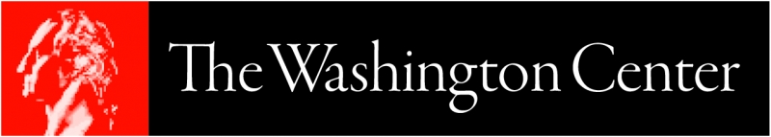

Press Release Template
for Sharing News About Student Participation in The Washington Center

[Newsworthy Headline, Approximately 100 Characters or Less]
Sample headlines:
- # [School Name] Students Participate in The Washington Center This [Spring/Summer/Fall]
- [School Name] Sends First Group of Students to The Washington Center
- [School Name] Sends Record # of Students to The Washington Center
[City, State] — This [spring/summer/fall], [number] of students from [School Name] will attend The Washington Center (TWC)’s Academic Internship Program. The students are:
- [Student First Name Last Name], a [name of major/s] major interning at [Internship Site Name]
TWC’s Academic Internship Program is composed of three components - internship, academic course and career readiness programming - each designed to help students translate their academic and professional interests into careers they love.
[School Name] has partnered with TWC since [Year] and [many OR # of] students have launched their careers through this partnership. [Insert quote from TWC Liaison - or other stakeholder - about the significance of the partnership with TWC for their students].
About [School Name]
[Insert boilerplate language from the institution]
About The Washington Center
The Washington Center is the largest and most established student internship program in Washington, D.C. Since our founding, we've helped more than 60,000 young people translate their college majors into career paths. We use our scale and expertise to customize each student’s experience to be truly transformative. Facebook Twitter LinkedIn

